SFWR ENG 4J03

Author: Kemal Ahmed

Instructor: Dr. Gowri Krishnasamy

Winter 2016

*Math objects made using* [*MathType*](http://www.dessci.com/en/products/mathtype/)*.*

Table of Contents

Abbreviations 1

Angle Modulation 1

Frequency Modulation 1

Phase Modulation 1

Amplitude Modulation 1

Generating SSB-SC 1

Frequency Discrimination Method 1

Phase Discrimination Method 1

Information Theory 1

Shannon-Fano 1

# Abbreviations

(O/P): Output

# Angle Modulation

**Signal to Noise Ratio (SNR)**: signal power / Pnoise



## Frequency Modulation

**Modulation**: the process of varying one or more properties of a periodic waveform, called the carrier signal, with a modulating signal that typically contains information to be transmitted

**Angular Frequency** [ω]: 2πf

**Message Angular Frequency** [ωm]: 2πfm

**Carrier Angular Frequency** [ωc]: 2πfc

**Angle Modulation**: frequency or phase modulation

**Frequency Modulation (FM)**:

* better for audio signals, needing kHz (300Hz - 3kHz)
* multiple sidebands: amplitude higher
* non-linear

**Demodulation**:

**Inductance** [L]:

**Capacitance** [C]:

**Message Frequency** [fm]:

**Carrier Frequency** [fc]: 

**Instantaneous Frequency** [fi]: fc + kf m(t)

**Angle** [θ]: unmodulated carrier

θi(t) = 2πfc t + ϕ

**Oscillator**: produces a signal that converts the digital message into analog signal

* requires very precise frequency and phase to match the carrier

**Difference Signal**: oscillator frequency – input signal

**Balanced Modulator**: frequency translations

**Bandwidth (BW)**: = upper sideband – lower sideband = 2fm

**FM Bandwidth** [BT]: BT = 2Δf + 2fm = 2Δf (1 + 1/β)

**Peak Frequency Deviation** [Δfc]: Δfc = kfAm = (βAc)2/R

**Narrow Band Frequency Modulation (NBFM)**:

**Wide Band Frequency Modulation (WBFM)**:

**Frequency Modulation index** [β]: (rad) max frequency deviation / fm

= Δf/fm × 100%

= phase deviation [Δϕ]

**Frequency Sensitivity** [kf]: (Hz/V) sensitivity of modulator

## Power

**Power**:

**Resistance** [R]: 1Ω by default

**Carrier Signal Power** [Pc]: Ac2/(2R)

**Power Spectral Density** [SM(f)]:

**Message Power** [Pm]: PUSB + PLSB

[PUSB]: m2/4

[PLSB]: m2/4

**Total Power** [Ptotal]: 

**Peak Power** [Pp]: 

**Harmonics**: when waves build up…

**Audible frequency range**:

**Audio modulating frequency range**:



Fourier

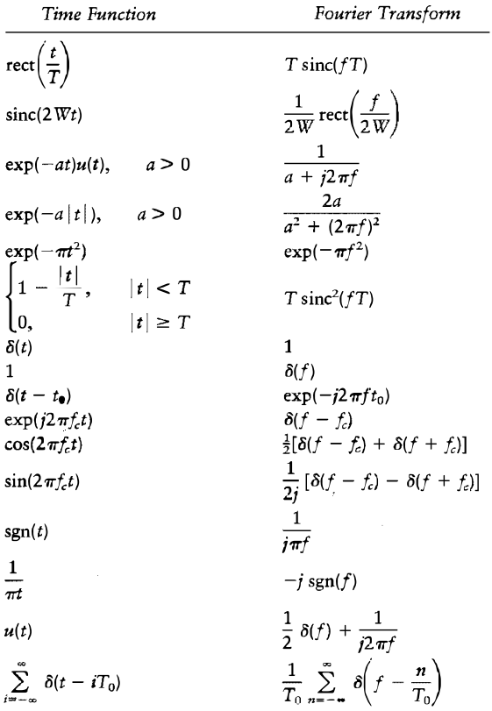



**Frequency-Division Multiplexing (FDM)**:

## Phase Modulation

**Phase modulation (PM)**:

**Phase Sensitivity** [kp]:

θi(t) = 2πfct + kp m(t)

S(t) = Ac cos (2πfct + kp m(t))

**Phase Deviation** [Δϕ]:

# Amplitude Modulation

**Amplitude Modulation (AM)**:

* modulated signal contains two side bands and an unmodulated carrier signal
* better for video signals (over the air), needing MHz, perhaps 5.5
* linear

Don’t look at phase shifts for AM, so you can convert between sin ↔ cos

**Maximum Amplitude** [Am]:

**Message Signal** [m(t)]: m(t) = Am cos(ωmt)

a.k.a. modulating signal, unmodulated signal, data signal, information signal

**Carrier Signal** [c(t)]: original carrier signal

**Modulated Signal** [s(t)]: Output (O/P)

s(t) = m(t) × c(t)

[AAM]: Ac + m(t)

**DSB-AM**: a.k.a. conventional AM



**Amplitude Modulation Index** [m]: 

**AM BW**: max – min = (fc + fm) – (fc – fm) = 2∙fm

**Band Pass Filter (BPF)**:

**Vestigeal Sideband Transmission (VSB)**: one side band along with just a trace of the other side band (a.k.a. **vestige**). This trace is useful for ensuring that important information is not cut off when reading  
  
Filters, such as BPF, tend to remove a little bit of the message. You can avoid this by extending the length of the transmission and including a trace of the opposite SB.

**Message Bandwidth** [W]: maximum message frequency, i.e. message

**SideBand (SB)**:

**Suppressed Carrier (SC)**: don't transmit carrier signal with the message signal, so less power, but complicated filter because you transmit the signals on the sidebands  
  
**Double SB-SC (DSB-SC)**: USB & LSB

**Single SB-SC (SSB-SC)**: transmit only one sideband frequency, usually a DSB through a BPF  
  
**Lower SB (LSB)**: (fc – fm)  
  
**Upper SB (USB)**: (fc + fm)

**Envelope Detection**: a demodulation method that converts AM to m(t), using c(t)

* Cannot be used with SC because envelope is no longer representing m(t)

## Generating SSB-SC

1. Frequency discrimination method
2. Phase discrimination method

### Frequency Discrimination Method



### Phase Discrimination Method

π/4 phase shift → product modulator → S1(x) → Sum → SSB-SC S(k)

**Phase** [ϕ]:

# Current

[IC]:

[IT]:

# Information Theory

**binits** [v]: binary bits

**Amount of Information** [Ik]: log2(1/Pk)

## Shannon-Fano

**Shannon-Fano code**: finds efficiency of code, listed with probabilities in decreasing order

**Ensemble**: source of the messages

1. Split into 2 groups as similar in size as possible without first rearranging. Sometimes it may be more efficient to put a smaller group on top because it is more probable and will require less bits.
2. Allocate 1s to one group and 0s to the other. Either put 0s on all the top groups or 1s in all the top groups
3. Split your groups into smaller groups
4. Continue partitioning until you only have groups of size one.

Since the bottom division is always larger, looking at the first bits will most likely be the same. Thus, flipping the order of the bits causes more variance, i.e. unique, increasing the probability that the identifying bits will come sooner while checking messages from left to right.

## Huffman Coding

[N~]: average number bits per message



**Code efficiency** [η]:



Reverse when transmitted.

**Entropy** [H]:

H = Itotal/L

= sum(Pklog2(1/Pk), k=1..m)



Properties:

1. Pk = 0 / 1 🡪 H = 0
2. When m symbols equally likely, i.e. symbols have equal probability:
   1. H = log2m
   2. Hmax = log2m

# Quantization

## Uniform Quantization

**Quantizer**: rounds the sampled amplitudes to whatever amount of decimals that you want

Round to nearest 2 decimal bits (0.00, 0.01, 0.10, 0.11):

0, 0.25, 0.25, 0.25, 0.25, 0.5, 0.5, 0.5, 0.5, 0.5, 0.75, 0.75

**Quantization**: truncates, rounds

**Quantization level** [q]: number of possible values within range, after rounding

**Staircase waveform**: vertical cliffs and plateaus climbing upwards with x

* First step is a half-step
* Used in quantization

**Step Size** [δ]:

**Quantization Error** [ε]: error from rounding

**Mid-tread**: origin is in middle of plateau, where error is sawtooth wave

– δ/2 < x(nTs) ≤ δ/2

xq(nTs) = 0

δ/2 ≤ x(nTs) ≤ 3 δ/2

xq (nTs) = δ

**Mid-rise**: origin is in middle of cliff, where error is negative sawtooth wave

0 < x(nTs) < δ

xq (nTs) = δ/2

## Quantization Error

**Quantizer Output** [xq(nts)]:

**Sampler Output** [x(nts)]:

**Noise Voltage** [Vnoise]:

**Noise Power** [Pnoise]: v2noise/R mean square value of noise voltage

E[ε2] = 

1. Error: 
2. Step size: 
3. δ/2 ≥ εmax ≥ δ/2. Note: uniform distribution
4. δ = 2xmax / q
5. **Noise Power** = v2noise/R ⇒ Mean square value =

↑SNR = signal power↑ / Pnoise↓

**Bit transmission rate** [r]: a.k.a. **signaling rate**

## Signal : Noise

**Normalized signal power** [S]:

**Normalized noise power** [N]:

S/N ⇒ 

δ = 2xmax / q = 2xmax / 2V





**Nyquist sampling criterion**: you’ll get aliasing if fm > **Nyquist rate**

**Nyquist rate**: 2∙fs

**Nyquist interval**:

**Nyquist frequency**: ½ fs of discrete processing system

If you have multiple messages, choose the highest one to be the rate to be doubled

# Pulse Code Modulation

**Pulse Code Modulation (PCM)**:

* Analog:
  + **Pulse Amplitude Modulation (PAM)**:
  + **Pulse Width Modulation (PWM)**:
  + **Pulse Position Modulation (PPM)**:
* Digital:
  + **Pulse Code Modulation (PCM)**:
  + **Delta Modulation (DM)**:
  + **Adaptive DM (ADM)**:
* Message signal
  + contains information to be transmitted
  + Analog signals, i.e. continuous with respect to time and amplitude
* Carrier Signal
  + Analog signal (analog modulation)
  + Pulse train (pulse modulation)

## Pulse Code Modulation

Message Source → Band limiting filter → Sampler → quantization → encoder → PCM signal → Regenerative repeater → Regenerative repeater → … → Regenerative repeater → PCM signal output

(O/P): output

PCM → regenerative repeater → decoder → LPF →

Analogous:

* PAM → AM
* PWM → FM
* PPM → PM

### Regenerative repeater

**Regenerative repeater**: amplitudes to make sure that the signal stays strong after travelling over large distances

brb tho

### Pulse Width Modulation

**Sampling Process**:

* Think Riemann Sum or amplifying instantaneous samples
* Change the amplitude of the carrier, such that the frequency, amplitude is constant, but width of the pulse is varied in accordance to the message signal

### Pulse Position Modulation

* Amplitude, width constant
* Frequency varied